P3 Report
Visualisation:
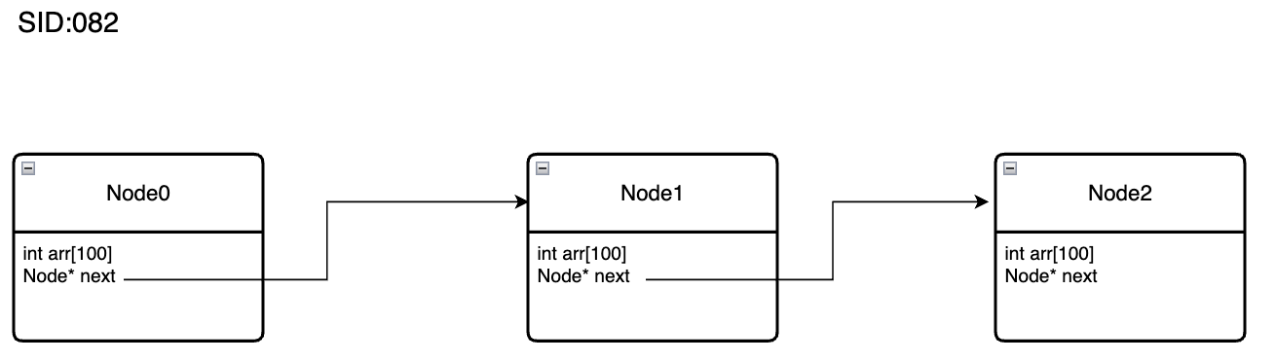
Evidence of Testing
